Final_assigment_submission

1. 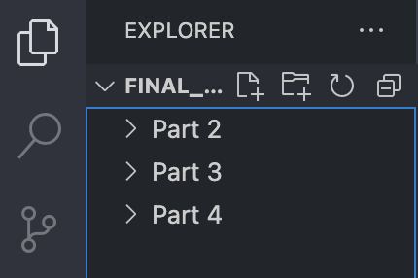
   1. Successfully loaded folder into VS Code
   2. 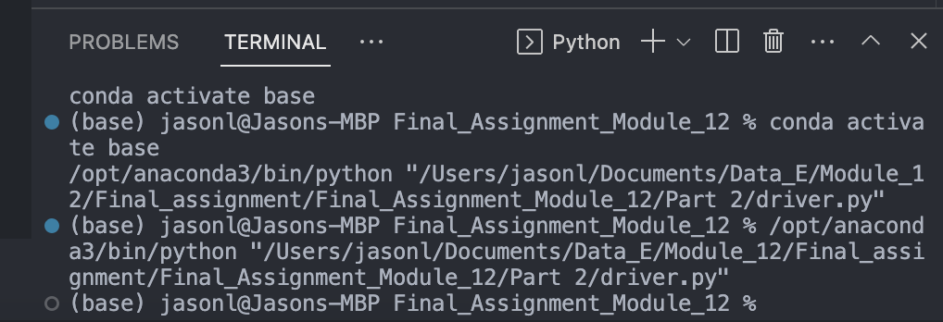
      1. Was able to successfully run driver file
   3. 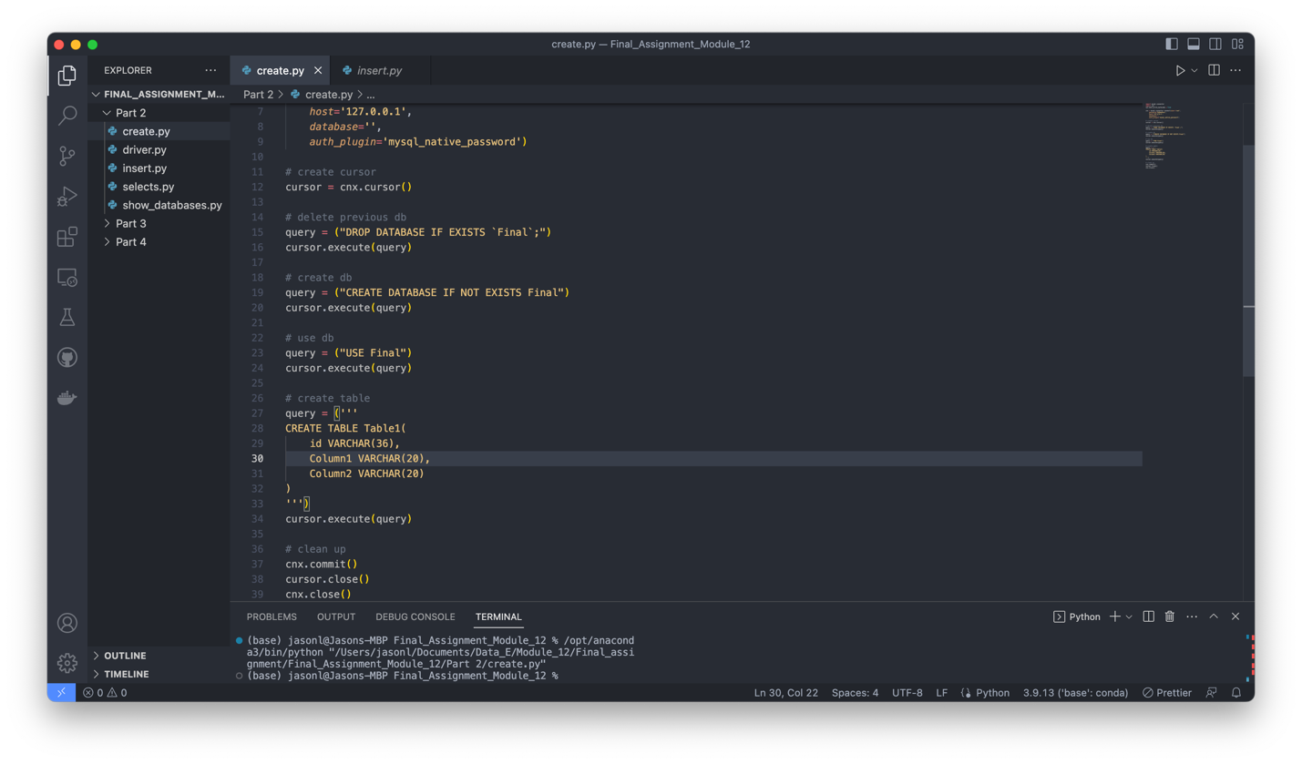
      1. Screenshot showing my completed code and that it was successfully run with no errors.
   4. 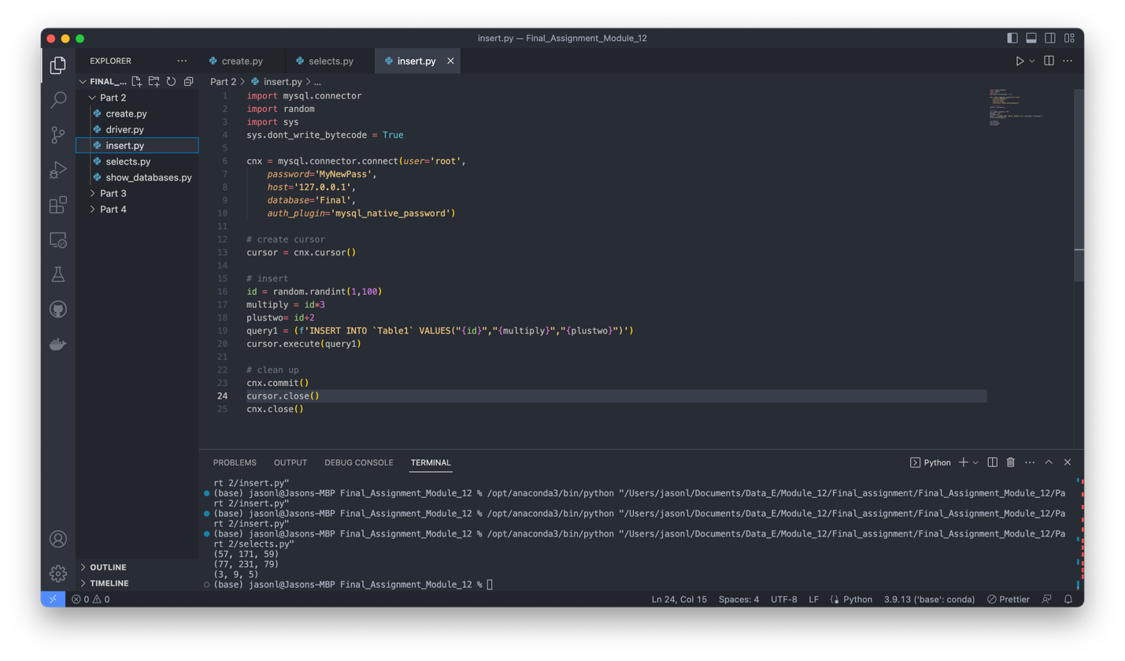
      1. Screenshot of my insert code. I ran the selects.py (after customizing the calls to my database) to show the three rows of entries.
   5. 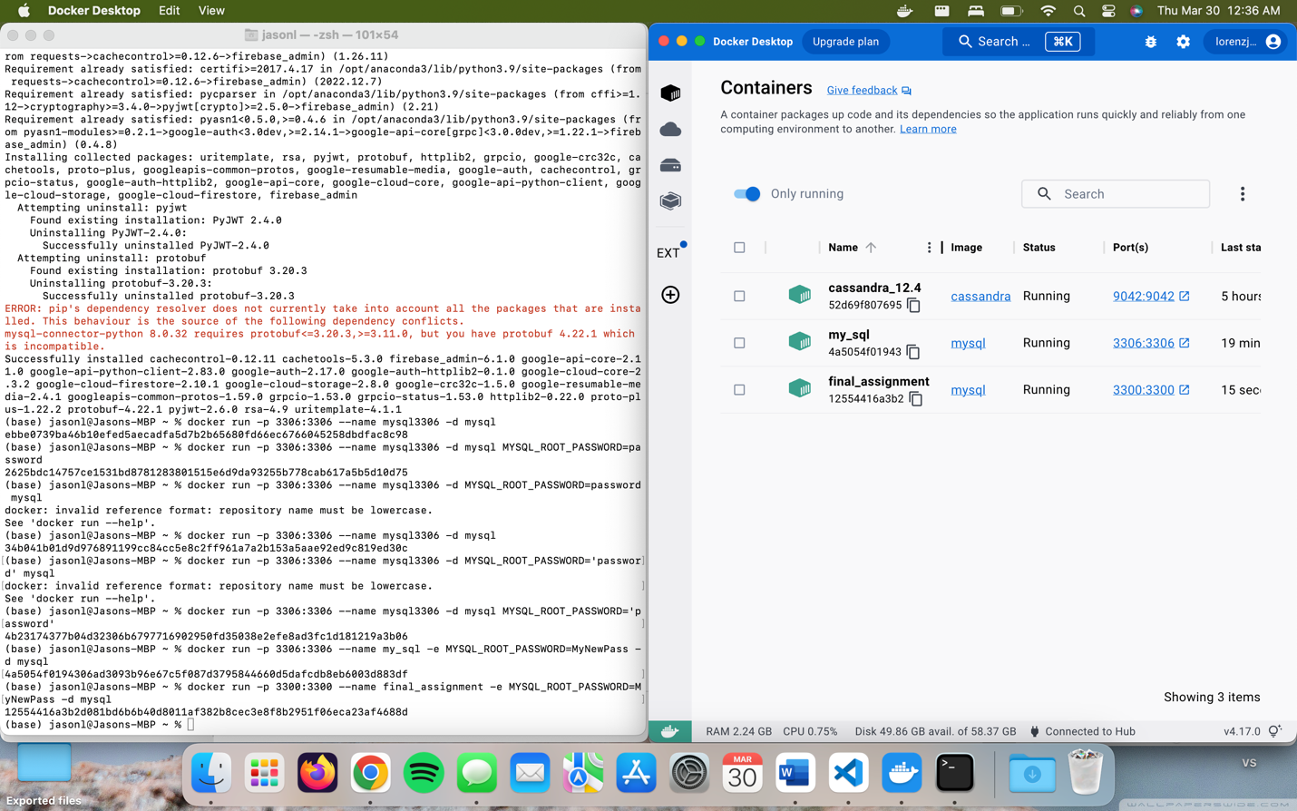
      1. Screenshot showing the command to create the container as well as the running container in my docker window.
   6. 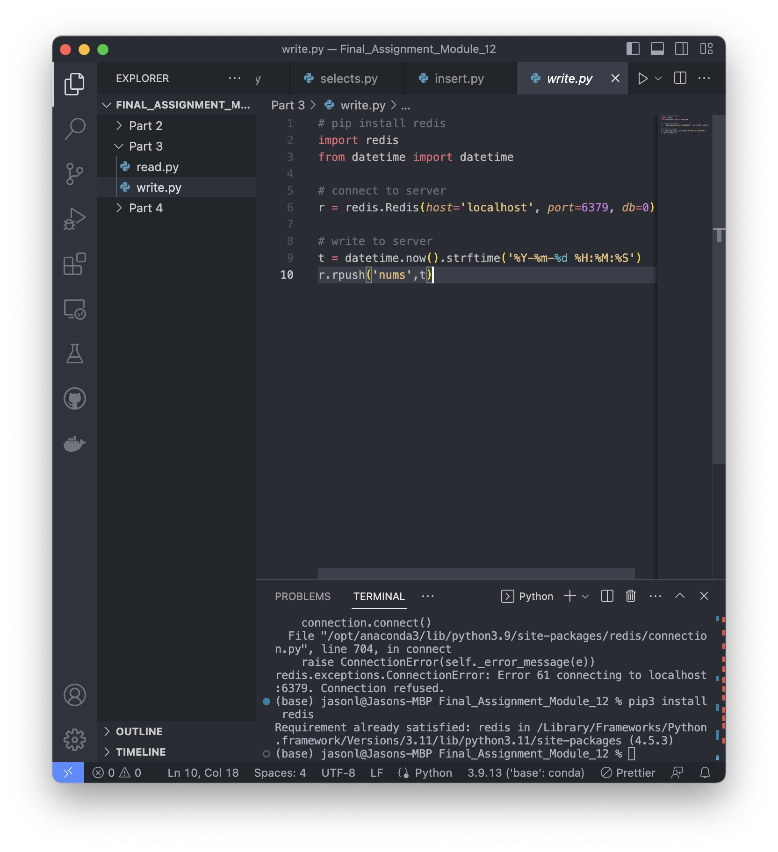
      1. Screenshot showing navigation and running of redis driver installer. I had it satisfied from activities previous in this module.
   7. 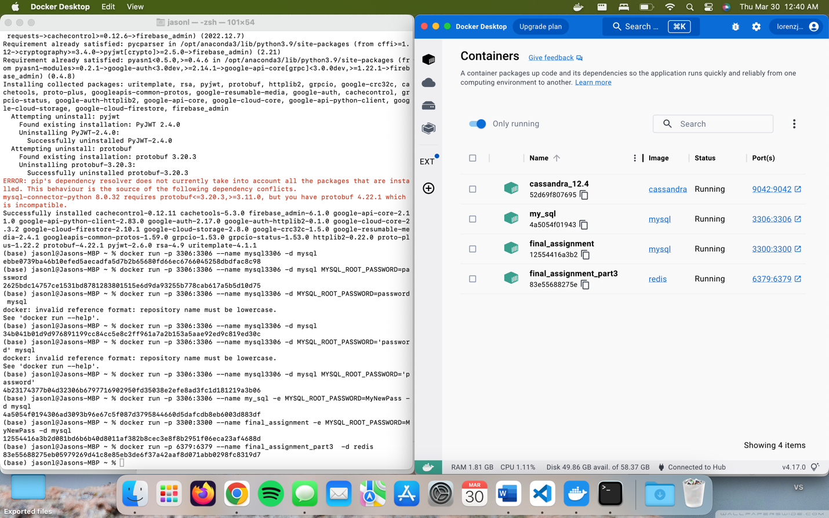
      1. Screenshot showing the command to initialize container and it successfully running in docker desktop
   8. 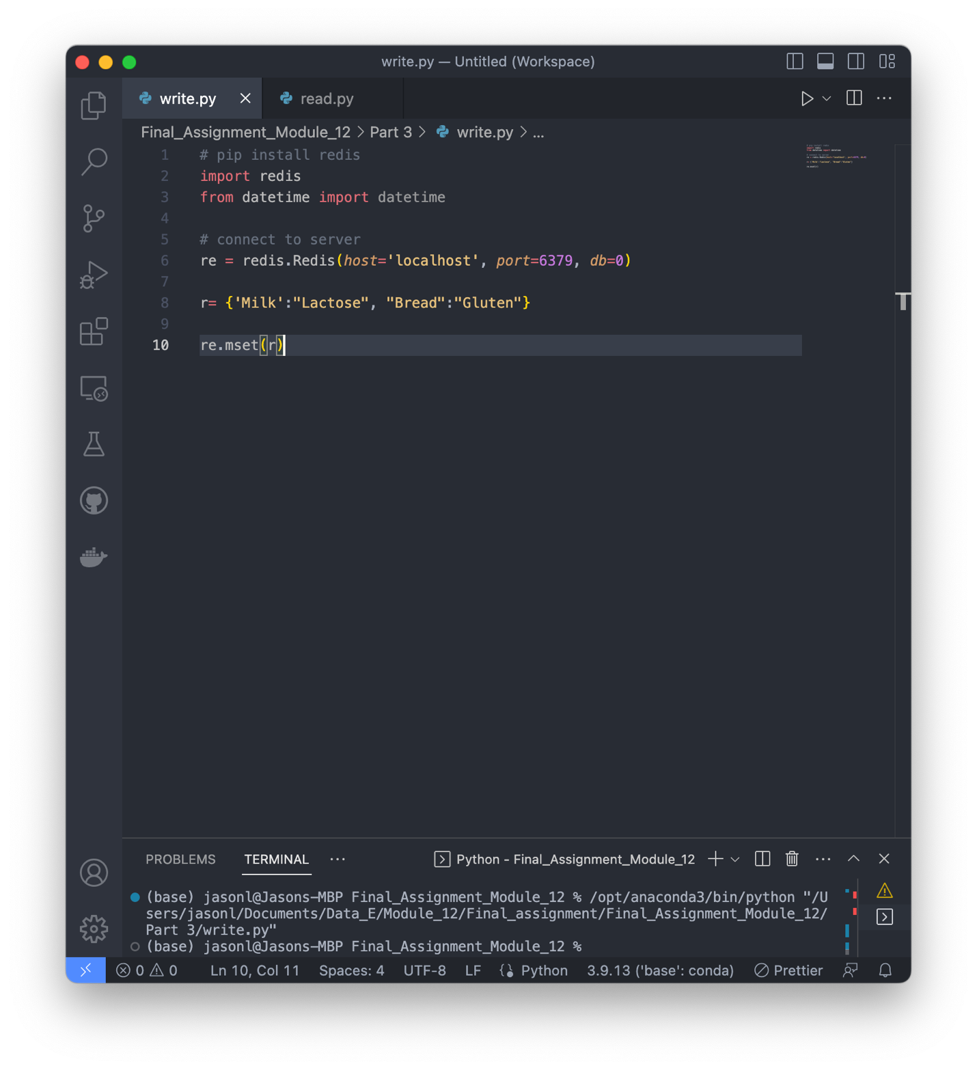
      1. Screenshot showing the code I wrote as well as terminal confirmation that it ran correctly
   9. 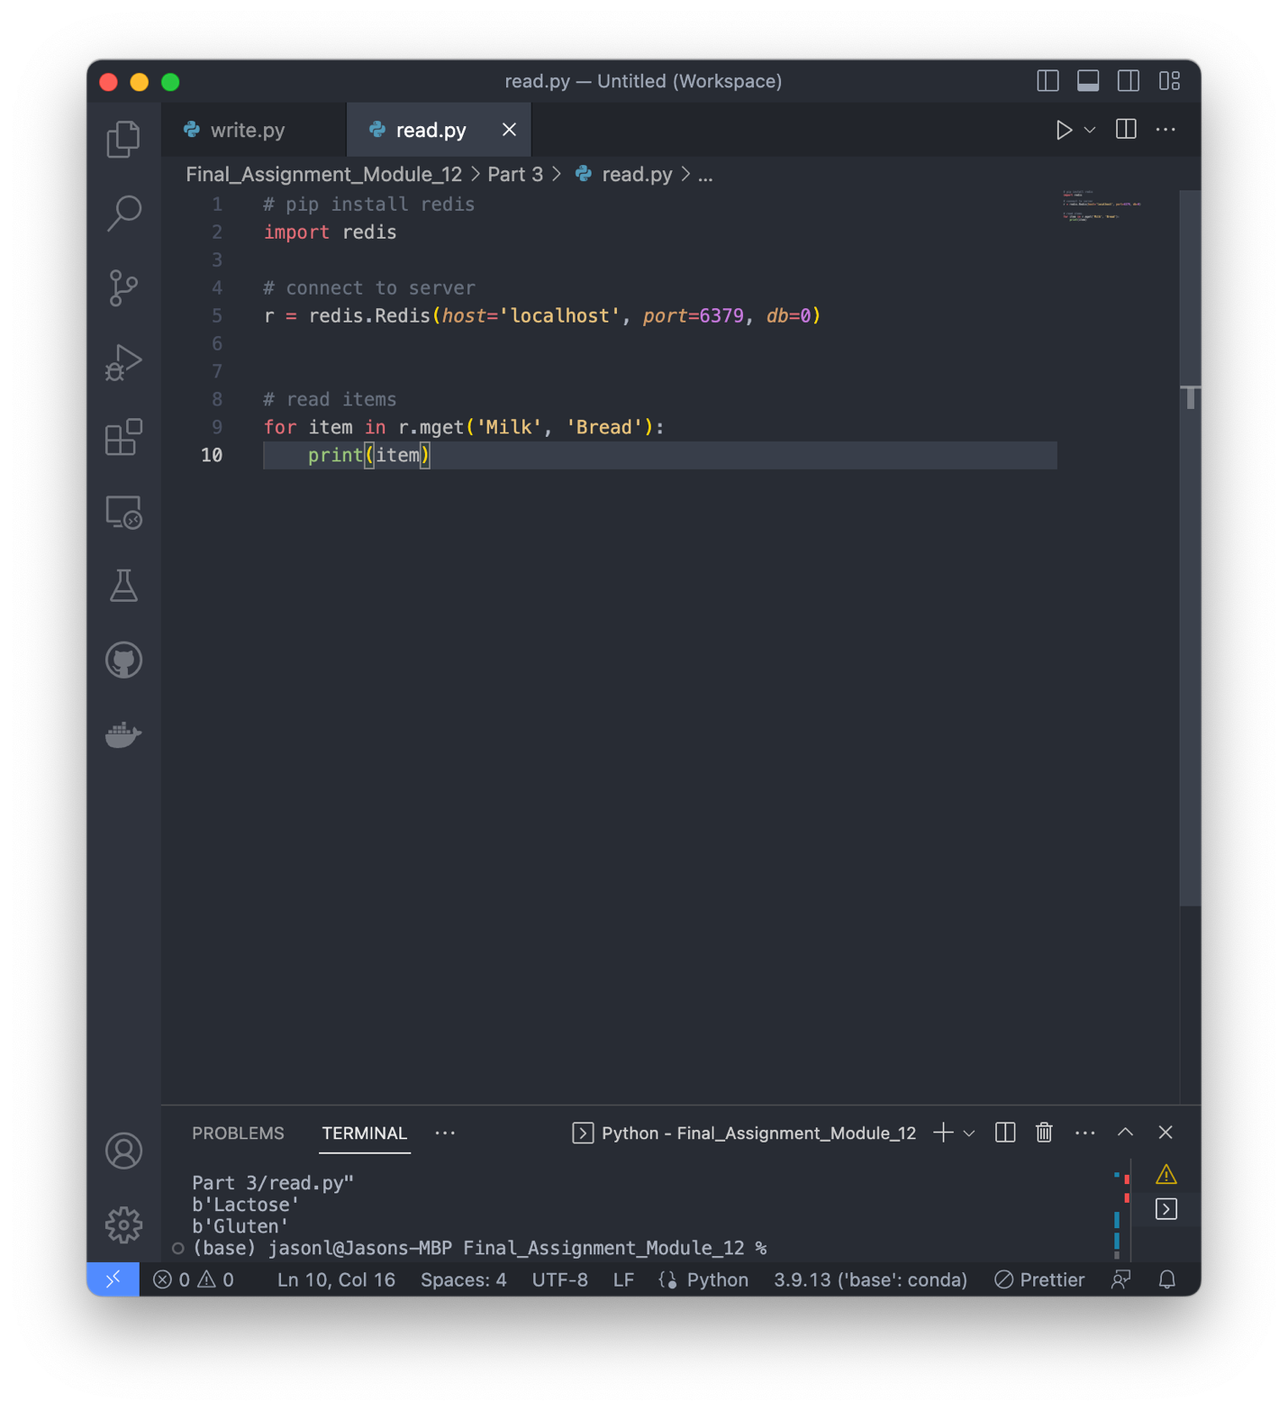
      1. Screenshot showing the code to get the values of the keys and the output in terminal
2. 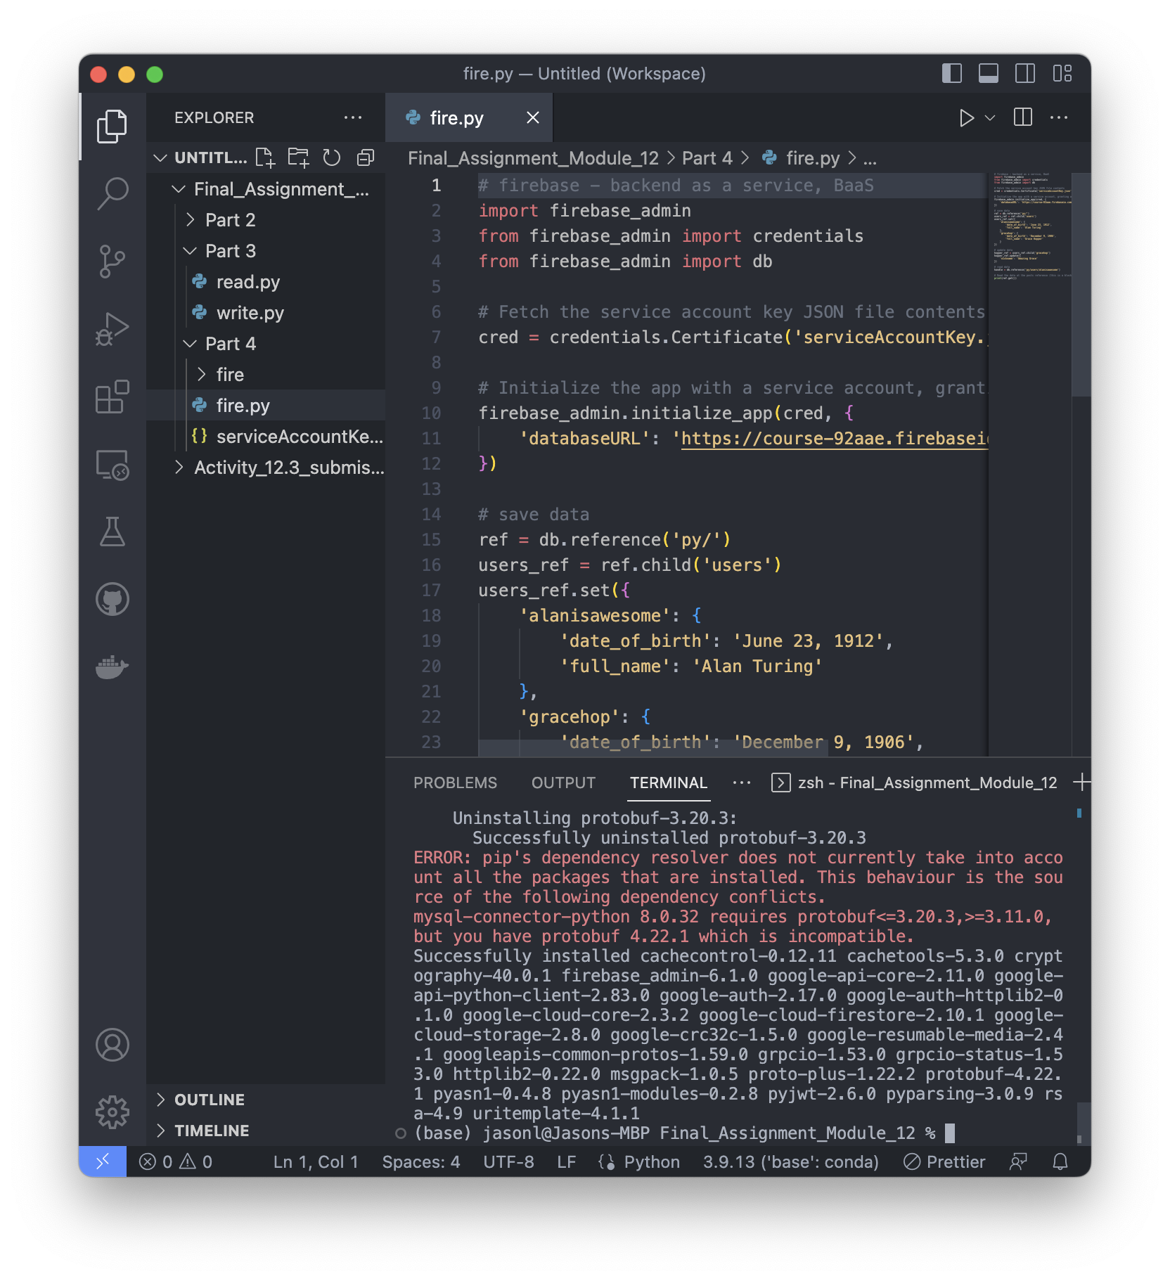
   1. Screenshot showing I opened the folder and ran the correct firebase driver install command
   2. 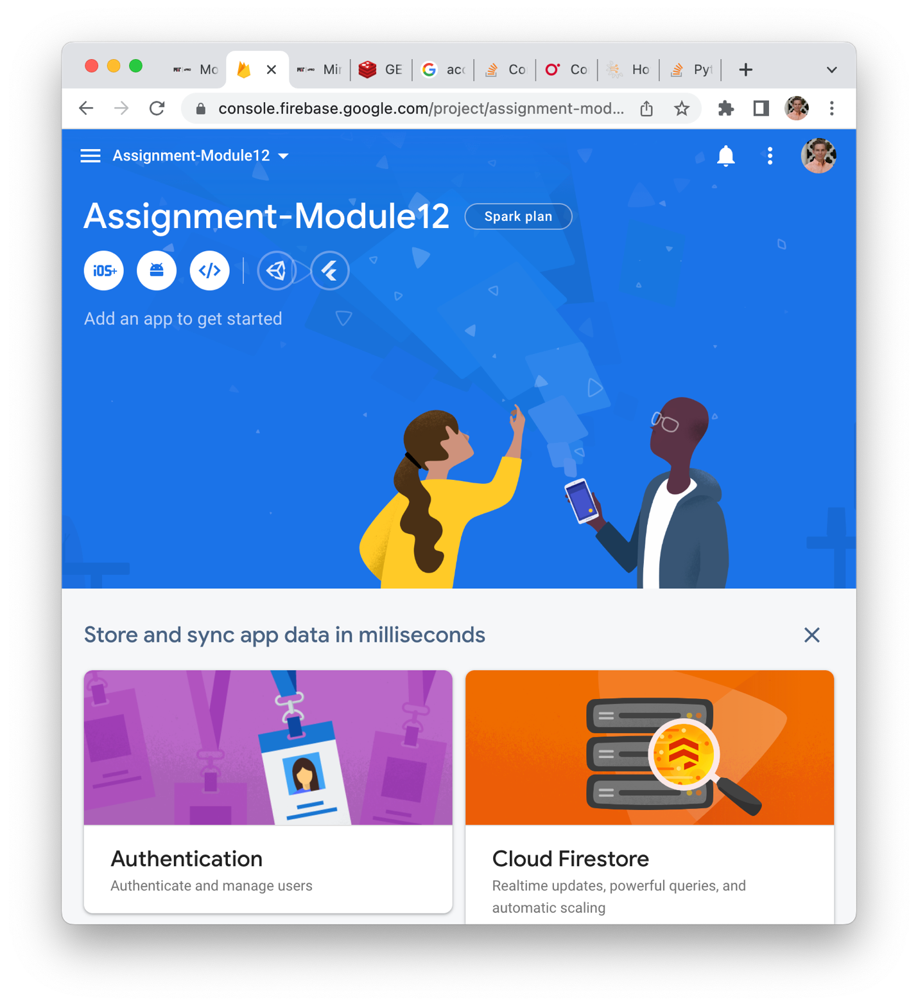
      1. Screenshot of created firebase database
   3. 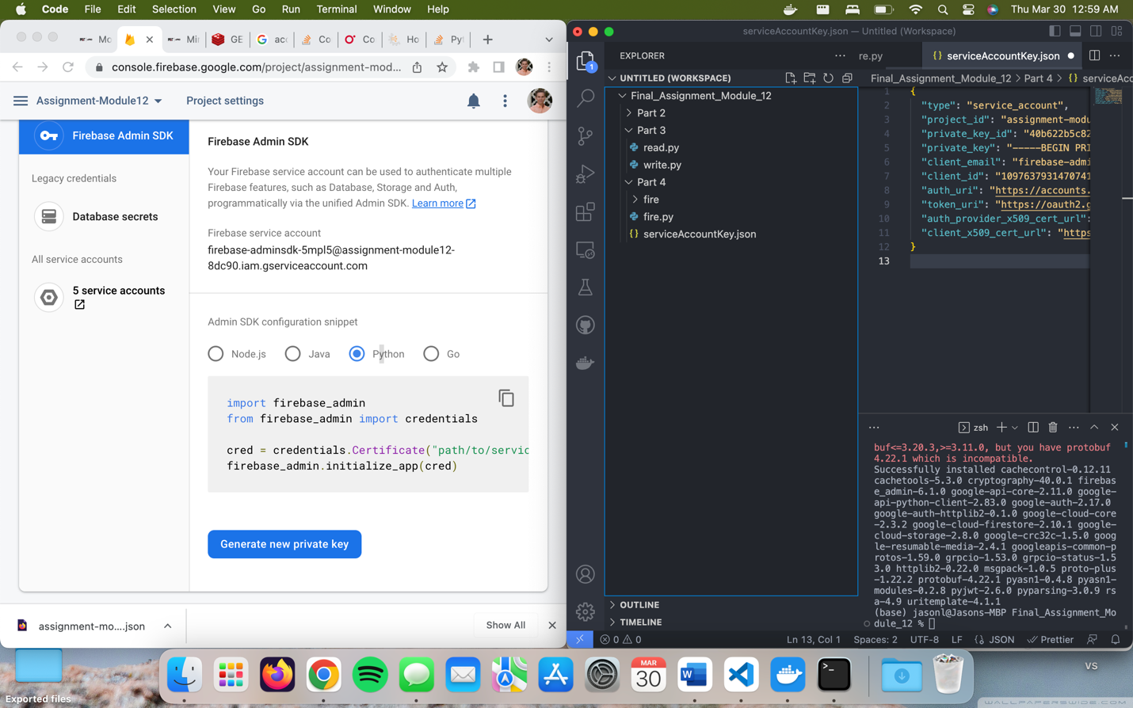
      1. Screenshot showing I correctly navigated to the page to get my key on the left and that I copied it into the correct JSON file hiding the actual key
   4. 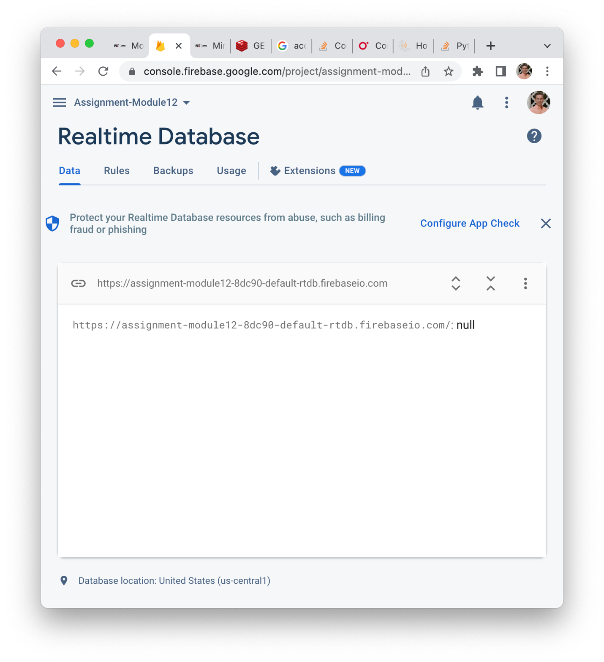
      1. Successfully created the database
   5. 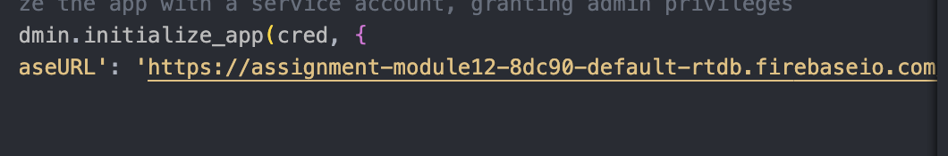
      1. Successfully copied the URL to the write file
   6. 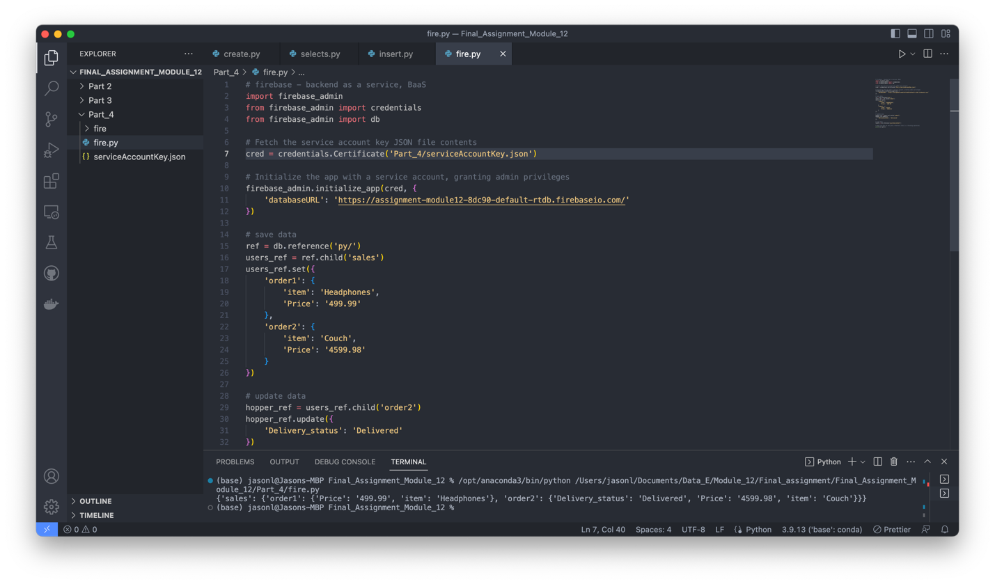
      1. Successfully updated the database. I needed to add a pathname to the cred function because it initially could not find the file.
   7. 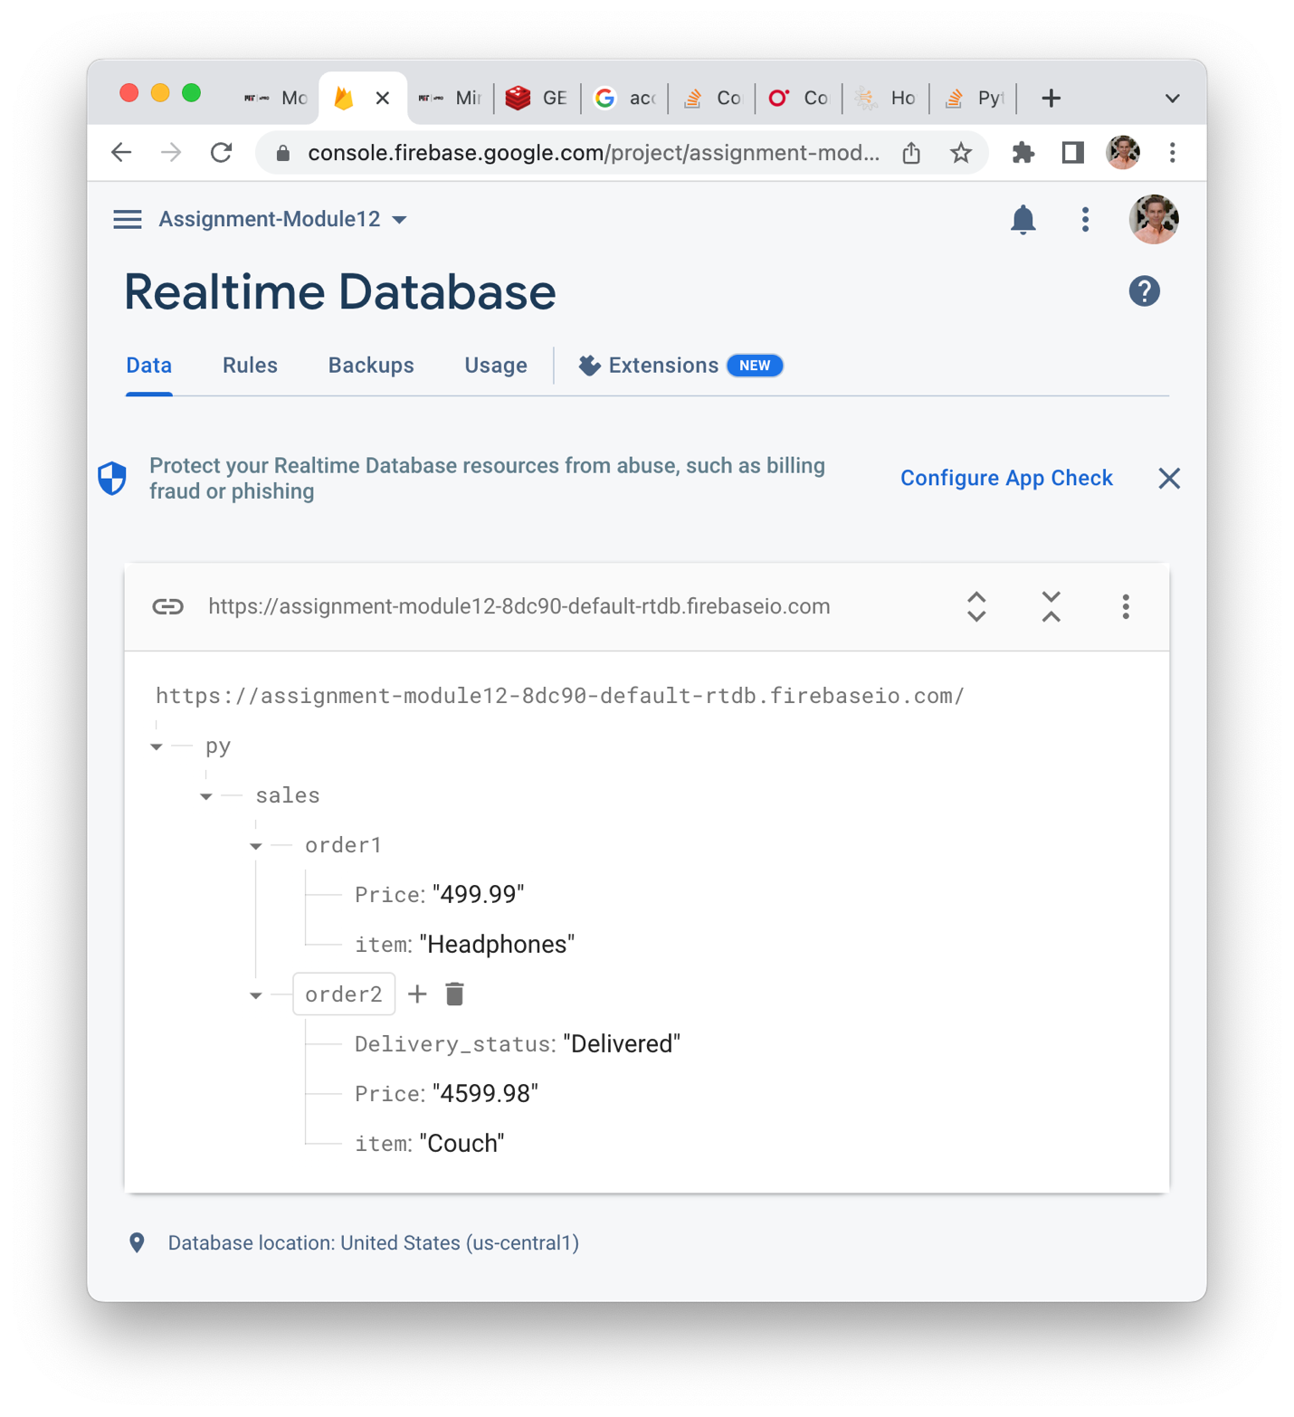
      1. Successful update of database in the real time database viewer